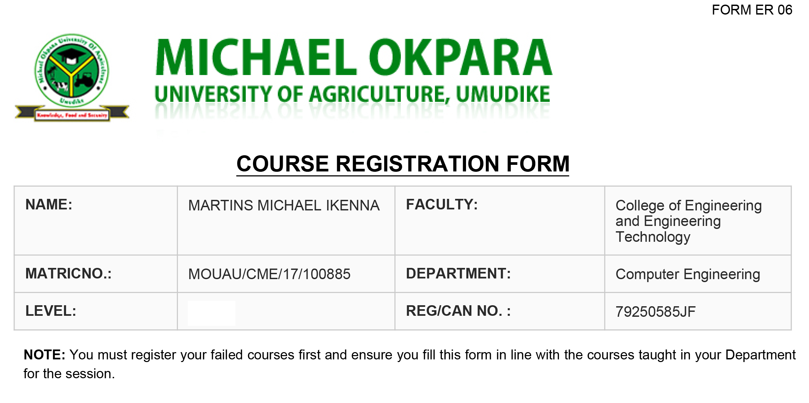

|  |  |  |  |
| --- | --- | --- | --- |
| **NAME:** | Hart Justman Chikanma | **FACULTY:** | College of Physical And Applied Sciences |
| **MATRICNO.:** | MOUAU/CMP/18/102474 | **DEPARTMENT:** | Computer Science |
| **LEVEL** | 200 | **REG/CAN NO:** | 85028050EI |

|  |  |  |  |
| --- | --- | --- | --- |
| **S/N** | **Course Code** | **Course Title** | **Credit Units** |
| 1 | MTH 211 | Mathematical Method I | 3 |
| 2 | CMP 211 | Computer Programming I | 3 |
| 3 | STA 212 | Principles of Statistics for Physical Sci. & Engr. | 3 |
| 4 | GSS 212 | Peace and Conflict Resolution | 2 |
| 5 | GSS 217 | Philosophy and Logic | 2 |
| 6 | CSC 218 | Introduction to Sequencial Programming | 2 |
| 7 | CSC 212 | Computer Hardware | 2 |
| 8 | PHY 212 | Modern Physics | 2 |
| 9 | CSC 213 | Introduction File Processing and Management | 2 |
|  |  | Total**:**21 | |

|  |  |  |  |
| --- | --- | --- | --- |
| **S/N** | **Course Code** | **Course Title** | **Credit Units** |
| 10 | GSS 121 | Use of English | 2 |
| 11 | MTH 221 | Elementary Differential Equations | 3 |
| 12 | MTH 222 | Introduction to Numerical Analysis | 3 |
| 13 | CMP 221 | Computer Programming II (FORTRAN) | 3 |
| 14 | CMP 222 | Structure Programming (Pascal/C) | 2 |
| 15 | CMP 226 | Discrete Mathematics Method | 2 |
| 16 | STA 224 | Pro. Theory (Statistics for Phy Sci. & Engr.) | 3 |
| 17 | GNT 221 | Introduction to Entrepreneurial Studies | 2 |
| 18 | PHY 222 | Electric Circuits & Electronics | 3 |
| Total**:**23 | | | |

Mutilations or erasures invalidate this form. Print and complete 5 (five) copies of this form.

Signature of Student Signature of HOD

Date: 22 November 2021 Date: 22 November 2021

Signature of Academic Date: 22 November 2021

Adviser

|  |  |  |  |
| --- | --- | --- | --- |
| 17 | CHM 124 | Practical Chemistry II | 1 |
| 18 | GSS 121 | Use of English II | 2 |
| 19 | GSS 126 | Social Science | 2 |
| 20 | UGC 121 | Farm Practice II | 1 |
| 21 | CSC 122 | Introduction to Information Technology | 2 |
| 22 | CSC 123 | Introduction to Problem Solving | 2 |
| 23 | MTH 123 | Introduction to Vectors | 2 |
| Total**:**21 | | | |

Mutilations or erasures invalidate this form. Print and complete 5 (five) copies of this form.

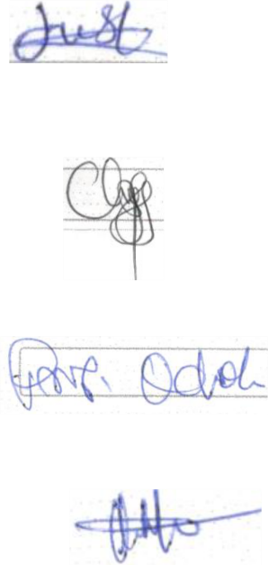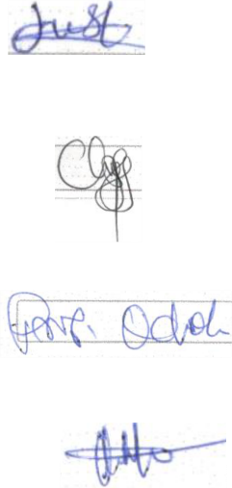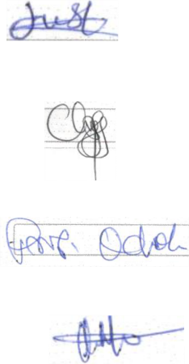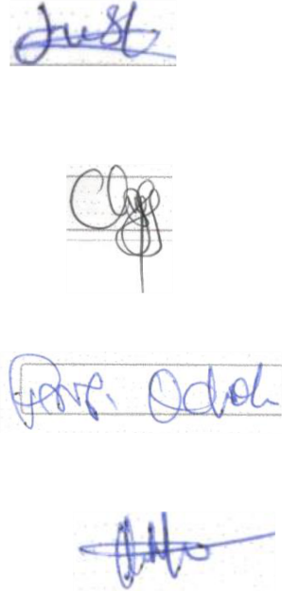

Signature of Student Signature of HOD

Date: 22 November 2021 Date: 22 November 2021

Signature of Academic Date: 22 November 2021

Adviser



|  |  |  |  |
| --- | --- | --- | --- |
| **Name:** | IHUNANYA MIRACLE .G | **Faculty:** | College of Engineering and Engineering  Technology |
| **Matric**  **No:** | MOUAU/CME/17/99280 | **Department:** | COMPUTER ENGINEERING |
| **Level:** | 500 | **REG/CAN**  **No.:** | 79116244ID |

**NOTE**: You must register your failed courses first and ensure you fill this form in line with the courses

taught in your Department for the session.

|  |  |  |  |  |
| --- | --- | --- | --- | --- |
| **S/N** | **Course Code** | **Course Title** | **Semester** | **Credit Units** |
| 1 | ENG 215 | Engineering Mechanics | 1 | 2 |
| 2 | CSE 500 | Final Year Project | 1 | 3 |
| 3 | CSE 510 | Computer Modeling and Simulation | 1 | 2 |
| 4 | CSE 511 | Solid State Electronics | 1 | 2 |
| 5 | CSE 512 | Computer Architecture | 1 | 2 |
| 6 | CSE 513 | Computer Engineering Law and Management | 1 | 2 |
| 7 | CSE 514 | Digital Telecommunication System | 1 | 2 |
| 8 | CSE 515 | Real Time Computing and Control | 1 | 2 |
| 9 | CSE 516 | Artificial Intelligence | 1 | 2 |
| 10 | CSE 517 | Operational Research | 1 | 2 |
| 11 | CSE 518 | Software Project Management | 1 | 2 |
| 12 | CSE 519 | Seminar | 1 | 1 |

**TOTAL 24**

|  |  |  |  |  |
| --- | --- | --- | --- | --- |
| **S/N** | **Course Code** | **Course Title** | **Semester** | **Credit Units** |
| 13 | CSE 500 | Final Year Project | 2 | 3 |
| 14 | CSE 520 | Computer Graphics | 2 | 2 |
| 15 | CSE 521 | Digital Computer Network | 2 | 2 |
| 16 | CSE 522 | Advanced System Programming | 2 | 2 |
| 17 | CSE 523 | Instrumentation Engineering | 2 | 2 |
| 18 | CSE 524 | Advanced Computer Writing Techniques | 2 | 2 |
| 19 | CSE 525 | Computer Installation And Maintenance | 2 | 3 |
| 20 | CSE 527 | Digital Signal Processing | 2 | 2 |
| 21 | CSE 528 | Assembler Translator and Compiler | 2 | 2 |
|  |  |  |  |  |

**TOTAL 20**

Mutilations or erasures invalidate this form. Print and complete 5 (five) copies of this form.

**Signature of Signature**

**Student:** ...................................................... **of HOD:** ......................................................

**Date:** 10th January 2022 **Date:**  10th January 2022

**Signature of**

**Academic Adviser**...................................................... **Date:** 10th January 2022